Rule #2
Its important to look people in the eye. It’s a sign of respect and confidence.
Activity #1
Mark either “Make Eye Contact” or “Do NOT Make Eye Contact” for each scenario.
Imagine yourself in each situation…
Situation | - Make Eye Contact | - Do NOT Make Eye Contact
- You meet a friend on the street…
You…
- You meet an older relative.
You…
- You give the cashier at the store money for your purchase
You…
- You take you rlunch try from the person working in the cafeteria
You…
- Your teacher asks you a question
You…
- You explain to your parents or boss why you didn’t finish your assignment.
You…
- You ask permission to go to a special event.
You…
- You tell your teacher or boss that you would like to volunteer for some extra credit work.
You…
- You explain to a friend why you can’t hang out after school.
You…
- You tell guests at your party that you’re really glad they could come.
You…

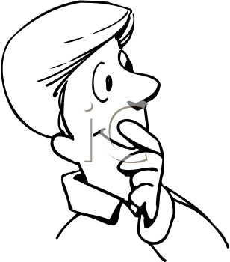
Now that you’ve made your markings, act out the scenarios above. What do those conversations look like? Sound like? Feel like?

