Level #1

In Level #1 you will earn your Parking Spot!
Here, you can choose your Smart Score Goal.

My Goal will be (circle one) : 80 / 90 / 100

Brain pop (Exponents) | Find the Movie Link Button on  Fordeducation.weebly.com | Fill out  Brain Pop Notes
ixl.com Exponents | (Level H) E.2  Evaluating Exponents | Give yourself a pat on the back! Keep it up!
ixl.com  Integers | (Level H) C.2  Number Lines with Integers | Keep up the good energy!  Jump up and down a few times!
ixl.com  Integers | (Level H) C.1  Understanding Integers | Hey Rock Star, Do 5 Jumping Jacks! GO
Level #1 Completed!
Go Grab your PARKING SPOT

Level #2

In Level #2 you will earn your Car Body! Make sure to take a look at the Body Shop to determine what Smart Score Goal you want to choose!

My Goal will be (circle one) : 70 / 80 / 90 / 100
Kohn Academy  Introduction to Order of Operations | Find the Movie Link Button on  Fordeducation.weebly.com | Fill out  Kohn Academy Notes
Brain Pop  Order of Operations | Find the Movie Link Button on  Fordeducation.weebly.com | Fill in  Brain Pop Notes
ixl.com  Order of Operations | (Level G) Q.1  Simplify Expressions using Order of Operations and parentheses | High Five yourself here
ixl.com  Order of Operations | (Level K) B.2  order of operations with integers | Tap a friend and give them a high five
ixl.com  Order of Operations | (Level I) I.8  simplifying expressions involving exponents | WOW! Nice work! Go Grab a Car based on your SmartScore!
Level #2 Completed!
Go Grab your Car Body!

Level #3
In Level #3 you will earn your Wheels (2)! Make sure to take a look at Willys Wheels to determine what Smart Score Goal you want to choose!

My Goal will be (circle one) : 70 / 80 / 90 / 100
Brain Pop Video  Equations with Variables | Find the Movie Link Button on  Fordeducation.weebly.com | Fill out  Brain Pop Notes
ixl.com  Variables | (Level H) P.1  Write variable expressions to represent word problems | Smile here!
ixl.com  Variables | (Level H) P.2  Evaluate variable expressions with whole numbers | Tap a friend and give them a high five
ixl.com  Variables | (Level H) P.4  evaluate variable expressions involving decimals, fractions, and mixed numbers | WOW! Nice work! Go Grab the type of Wheel you earned with your Smart Score!
Go Grab ONE Wheel!
Use your Smart Score to see the style you’ve earned!
Level #3 Continued …
(earning the second wheel)

Kohn Academy  (1) Equations  -solving x+5=54 | Find the Movie Link Button on  Fordeducation.weebly.com | Fill out  Kohn Academy Notes
Kohn Academy  (2) Equations | Find the Movie Link Button on  Fordeducation.weebly.com  You may STOP after watching for 4:27. You do NOT need to watch the whole video! | Fill out  Kohn Academy Notes
ixl.com  Variables | (Level H) P.5  Solve one-step equations with whole numbers | You deserve a signature. Get one from a friend or teacher here  ____________
ixl.com  Variables | (Level H) P.7  evaluate multi-variable expressions | WOW! Nice work! Keep it up Smarty Pants!
ixl.com  Variables | (Level H) P.8  solve two-step equations | You deserve a GOLD STAR! That was a hard one!!!
Go Grab your second Wheel!
Use your Smart Score to see the style you’ve earned!
Level #4
In Level #3 you will earn your DOOR! Make sure to take a look at Door Galore to determine what Smart Score Goal you want to choose!

My Goal will be (circle one) : 70 / 80 / 90 / 100
Brain Pop Video  Smile | Find the Movie Link Button on  Fordeducation.weebly.com | No notes needed.  Smile here
ixl.com  Variables | (Level H) P.12  evaluate expressions involving integers | Smile again here!
ixl.com  Variables | (Level H) P.13  solve equations involving integers | Do a dance here. Yes, get up and show off. Inspire your friends!
Go Grab a DOOR!
Use your Smart Score to see the style you’ve earned!

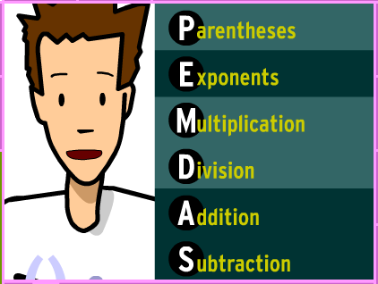
ally
unt
lease
xcuse
y
ear

